

Emergency Management and Evacuation Policy and Procedures

National Quality Standard
Element | 2.2.1 | Supervision - At all times, reasonable precautions and adequate supervision ensure children are protected from harm and hazard.
Element | 2.2.2 | Incident and emergency management - Plans to effectively manage incidents and emergencies are developed in consultation with relevant authorities, practised and implemented.
Element | 3.1.1 | Fit for purpose - Outdoor and indoor spaces, buildings, fixtures and fittings are suitable for their purpose, including supporting the access of every child
Element | 6.2.3 | Community engagement - The service builds relationships and engages with its local community.
Element | 7.1.2 | Management Systems - Systems are in place to manage risk and enable the effective management and operation of a quality service
 | 7.1.3 | Roles and responsibilities - Roles and responsibilities are clearly defined, and understood, and support effective decision-making and operation of the service.
 | 7.2.3 | Development of professionals - Educators, co-ordinators and staff members’ performance  is regularly evaluated and individual plans are in place to  support learning and development.

National Law
Section | 165 | Offence to inadequately supervise children
Section | 167 | Offence relating to protection of children from harm and hazards

National Regulations
Regs | 97 | Emergency and evacuation procedures
Regs | 98 | Telephone or other communication equipment
Regs | 168(2)(e) | Policies and procedures in relation to emergency and evacuation including the matters set out in regulation 97
Regs | 170 | Policies and procedures to be followed
Regs | 171 | Policies and procedures to be kept available
Regs | 172 | Notification of change to policies or procedures

Aim
In the event of an emergency at the service, we aim to manage the situation in a rehearsed, timely, calm and safe manner to secure the safety of each person at the service. Emergencies may require us to evacuate, lock out or lock down the premises. The safety and wellbeing of each child and adult at the service is paramount above any other consideration in the time of an emergency or evacuation. Any other procedures will be carried out only if it is safe to do so.

Definitions
“Authorised nominee” - a person who has been given permission by a parent or family member to collect the child from the service. Source: National Law (Section 170)
“Parent” - in relation to the child, includes: a guardian of the child; and a person who has parental responsibility for the child under a decision or order of a court. For regulation 99, ‘parent’ does not include a parent who is prohibited from having contact with the child. Source: National Law (Definitions)
“Direct Egress” - means the ability to move and directly exit to an assembly area that is at the same level as the education and care service and is outside the service premises and away from the building. This does not include travelling through sets of stairs (including fire isolated stairwells), busy occupied areas, traffic or other hazards, or obstructions. Source: ACECQA Guide to the NQF
“Emergency” - an incident, situation or event where there is an imminent or severe risk to the health, safety or well-being of a person at the service (e.g., a flood, fire or a situation that requires the service premises to be locked down or other type of emergency response). Source: ACECQA Guide to the NQF
"Emergency drill/rehearsal” - a process to rehearse the possible emergency scenarios or events, designed to help clarify roles and responsibilities, provide training and test the adequacy of the emergency response. Source: ACECQA Policy Guidelines: Emergency and Evacuation
“Emergency Services” - includes ambulance, fire brigade, police and state emergency services. Source: ACECQA Policy Guidelines: Emergency and Evacuation
“Evacuation diagram/plan” - an evacuation plan is used where it is deemed necessary to evacuate the immediate area ore building. Source: ACECQA Policy Guidelines: Emergency and Evacuation
“Evacuation route” - Continuous path of travel (including exits, public corridors) from any part of a building to a safe place. Source: ACECQA Policy Guidelines: Emergency and Evacuation
“Harm” - Physical or mental injury; hurt. Source: ACECQA Policy Guidelines: Emergency and Evacuation
“Hazard” - a danger or risk, even though often foreseeable. Source: ACECQA Policy Guidelines: Emergency and Evacuation
“Lock Down”- a security measure taken during an emergency to prevent people from leaving or entering a premises until the threat or risk has been resolved. Source: ACECQA Policy Guidelines: Emergency and Evacuation
“Lock Out” - a security measure taken during an emergency to prevent people from entering a premises until the threat or risk has been resolved. Source: ACECQA Policy Guidelines: Emergency and Evacuation
“Multi-storey building” - a building with more than two storeys, including the ground floor. Each level of a split-level storey (or mezzanine), is counted as one storey. For these purposes, the ground floor is the first storey, the first floor is the second storey, and so forth. Source: ACECQA Policy Guidelines: Emergency and Evacuation
“Risk” - Exposure to the chance of injury or loss; a hazard or dangerous chance. Source: ACECQA Policy Guidelines: Emergency and Evacuation
“Risk assessment” - assessing the risk means working out how likely it is that a hazard will harm someone and how serious the harm could be. Source: ACECQA Risk assessment template: Excursions

Intersection with other policies
Bushfire or Grassfire Policy
Bush Kindy Policy
Child Safe Policy
Emergency Service Contact Policy
Enrolment and Orientation Policy
Lockdown Policy
Incident, Injury and Trauma and Illness Policy
Administration of Authorised Medication Policy
Death of a Child Policy
Medical Conditions Policy
Physical Environment (Workplace, Learning and Administration) Policy

Implementation
Our service has strict measures and procedures in place to ensure the safety, health and well-being of children, staff and visitors during emergencies and evacuations. Specifically, we:
- Conduct thorough risk assessments in line with the National Regulations
- Follow best practice emergency planning and management, namely the Australian Standard AS3745:2010 Planning for emergencies in facilities, as well as guidance from ACECQA and regulatory authorities
- Have a comprehensive Emergency Management Plan that includes clear procedures for dealing with a range of emergencies
- Have an Emergency Communication Procedure
- Conduct quarterly emergency drills for evacuations and other emergencies
- Have defined roles and responsibilities for staff, volunteers, students and families
- Train staff, volunteers and students on our policies and procedures, both at induction and at regular intervals
- Communicate our emergency policies and procedures to the children and families
- Ensure that our emergency equipment – such as fire extinguishers, blankets, Emergency Kits – are maintained and tested according to instructions
Monitor and audit compliance and strive for continual improvements to our practices.
Risk assessments
We will conduct a risk assessment of potential emergencies that are relevant to our service at least once every 12 months and soon as practicable after becoming aware of any circumstances that may affect the safe evacuation of children from our service. A record of each risk assessment conducted will be kept, in line with our regulatory obligations.

We will ensure that children are protected from risks, and that any newly identified risks are communicated to the nominated supervisor and approved provider as soon as practicable. The approved provider must ensure that any necessary updates are made to this Policy and Procedure.
Our service uses the template at Appendix D when we conduct our risk assessments.

Risk assessment areas to consider
Risk assessments must identify and assess the risks of potential emergencies and specify how the risks will be minimised and managed.

Possible emergencies including:
- Natural disasters such as earthquake, flood, bush fire, extreme weather and storms
- Personal injuries and threats, suspicious mail, siege, bomb scare
- Chemical spills, biohazards, fire, gas leak, explosion.
Potential hazard during emergencies including:
- Heavy items falling particularly if they are stored high
- Hazardous materials leaking
- Communication/power outages or live wires
- Debris blocking preventing safe evacuation
- Structural damage to buildings.

Emergency Management Plan
Our Emergency Management Plan will be based on all identified risks and includes appropriate responses including evacuation, lockdown, lockout and shelter-in-place, and drill and training schedules. Where appropriate, we will consult with local emergency services (e.g., fire, police, ambulance), local government, community leaders and other relevant agencies for advice about issues like evacuation routes, assembly points and accessibility for adults or children with special needs.

Our Emergency Management Plan will include:
- Emergency contact details for people who have specific roles or responsibilities.
- Contact details for local emergency services
- A description of how we will alert people to an emergency, e.g., siren/bell
- Emergency procedures (see Appendix A). We may discuss our procedure - for example, evacuation point/route and alternatives - with local emergency services, community leaders and/or other relevant authorities, or access their online resources to ensure our procedures are robust, and accessible for adults or children with special needs
- How we will assist any child or person with special needs
- An Evacuation Diagram (see below for details) based on service floor plans showing the location of fire equipment, emergency exits and assembly points
- Processes to ensure staff are trained in our emergency procedures
- Processes we will follow after an incident
- Procedures we will follow to test the Emergency Management Plan and familiarise children and staff with the Plan

Evacuation Diagram
The Evacuation Diagram of the floor or area will include the following elements and will be at least A4 size:
- Title, e.g. Evacuation Diagram
- Designated exits in green
- Hose reels, hydrants, extinguishers, fire blankets in red
- “You are here” location
- Location of assembly area(s) including shelter in place location (stated pictorially or in words)
- Location of communication equipment in red
- Legend with the symbols used
- Date Diagram completed and when it will be reviewed
- If the Diagram includes additional elements, including those listed below, it will be at least A3 size:
- Paths of travel in green
- Location of First Aid Kits
- Emergency information (e.g., phone numbers, procedures).

Displaying information from the Emergency Management Plan
Relevant information from the Emergency Management Plan is displayed prominently at our service to ensure it can be easily identified and is accessible to all educators, staff, visitors, volunteers and families. Relevant information includes:
- Emergency service telephone numbers which will be displayed near telephones
- Evacuation procedures and diagrams which will be displayed near each exit. The Evacuation Diagram will be displayed at a height not less than 1200 mm and not more than 1600. It will also be oriented correctly in relation to the emergency exit, the ‘You are here’ point and the assembly area(s).
Emergency and Evacuation Procedures
Staff, volunteers and students will implement the Emergency and Evacuation Procedures during an emergency to protect children, each other and visitors to our service, and to ensure compliance with all regulations.

The following procedures are detailed at Appendix A:
- Emergency Evacuation procedure
- Lockout procedure (see the separate Lockdown Policy for our Lockdown Procedure)
- Shelter-in-Place procedure
- Emergency response procedures (what to do in specific emergencies: fire, severe weather, storms, flooding, pandemic, bomb/chemical threat, major external and internal emissions/spills, earthquake, medical emergencies, intruder/personal threat.

Emergency Communication Procedure
Our Emergency Communication Procedure is at Appendix B.
The approved provider will ensure there is access to reliable communication channels in the event of an emergency by maintaining access to a telephone (such as fixed-line telephone, mobile phone, satellite phone, 2-way radio, video conferencing equipment) at all times.
The main telephone is located in Office/Foyer area. If there is a complete loss of electricity and the telephones are not available, a mobile phone will be available and ready to use at all times to ensure educators can make emergency contact.
Emergency Kit
The nominated supervisor will ensure an Emergency Kit includes:
- Current emergency contact details for each child (open and close folder)
- Employee and next of kin contact details (open and close folder)
- Emergency service telephone numbers (see sa.gov.au for national numbers)
- Working torch and spare batteries
- Fully stocked first aid kit
- Administration of medication records and medical management plans (medical folder)
- Drinking water
- towels
- Gloves
- Smoke mask/goggles
- Portable radio and torches - battery-powered, solar or wind-up
- Spare batteries
- Whistle
- Pen and paper
- Insurance policy
- Alcohol based hand sanitiser.
- Sunscreen
- Insect repellent
- Nappies/wipes/change mat
- Infant cups

The nominated supervisor will ensure the Kit contains a list of items that must be added at the last minute in an emergency. Items will include:
- Attendance registers for children, staff and volunteers (open and close folder)
- Extra medication bag for staff and children
- Open and close folder that contains emergency plan, contact numbers and emergency plans.

The nominated supervisor will include the requirement to check batteries, food, water, sunscreen and insect repellent in the diary note for quarterly emergency rehearsals and replace these items if necessary.

Emergency and evacuation rehearsals
The service will add to each child’s sense of security, predictability and safety, and ensure all educators and staff are familiar with our emergency procedures, by conducting evacuation drills at least every three months.
If necessary, the nominated supervisor will prepare a risk assessment to identify and manage risks that may arise in emergency drills and evacuation points.
The nominated supervisor will develop a schedule for conducting drills for the different types of emergencies identified in the Emergency Management Plan and will diarise to ensure these are completed. All rehearsals and drills will be recorded and available for inspection.
The drills will:
- Take place at various times of the day and week (rather than always on a Tuesday at 10am, for example) to ensure all children and staff members get the opportunity to rehearse. Rehearsals may also be conducted when families are present to help them become familiar with the emergency procedures. All persons present at the service during the evacuation drill must participate.
- Be documented and assessed against specific outcomes using the checklist at Appendix C. We will appoint an observer to evaluate our drills using the checklist at Appendix C
- Be immediately followed by a debriefing session, if possible, to identify any improvements that may be made. Any training needs will be identified, and action will be taken to implement the relevant training

Information sharing, training and monitoring
The nominated supervisor will include the Emergency Management and Evacuation Policy and Procedures in staff inductions and ensure staff, volunteers and students receive practical training in relation to the requirements, including how to identify and manage risks. The nominated supervisor also implements an ongoing training program tailored to each staff member’s needs and goals, which are identified through regular performance reviews.

At orientation, parents will be provided with the Emergency Management and Evacuation Policy and Procedures. Staff and family can access the risk assessments we conduct. Where appropriate, visitors will also be made aware of the emergency response procedures.

Our Emergency Management Plan will be tested every quarter and reviewed at least annually and as soon as practicable after an emergency event. Other scheduled training for all staff, students and volunteers will take place annually, e.g., how to use fire extinguishers, fire blankets and other emergency equipment, communication arrangements, identifying assembly points and the location of emergency equipment, first aid arrangements and how to turn off the electricity and gas supplies. All new staff, students and volunteers will receive training during their induction and refresher training will take place at least annually. (Note – our Incident, Injury, Trauma and Illness Policy describes our service’s training arrangements for First Aid).

We will use discussions to familiarise children with our evacuation and emergency procedures as well as regular rehearsals.

The approved provider and nominated supervisor will monitor staff to ensure they are following our policies and procedures for emergencies and evacuations. They will act quickly to fix any issues and will give staff any extra support or training they need to comply. Volunteers and students are also required to comply with all service policies and procedures.

We will keep a record of all actual and rehearse emergencies, training and risk assessments, which can be accessed by staff, volunteers and families.

Roles and responsibilities
Responsibilities | Role
Ensure our service meets its obligations under the Education and Care Services National Law and Regulations, including to take every reasonable precaution to protect children from harm and hazards likely to cause injury and ensure children are adequately supervised at all times. | Approved Provider  Nominated Supervisor
- Ensure that our service has policies and procedures in place for emergencies and evacuations that address specific areas set out in the National Regulations - i.e., this Emergency Management and Evacuation Policy and Procedures will be in place.  - Ensure our procedures set out instructions for what to do in an emergency and include an emergency and evacuation floor plan. | Approved Provider
Take reasonable steps to ensure that nominated supervisors, staff and volunteers follow, and can easily access, the Emergency Management and Evacuation Policy and Procedures, including by:  - Providing information, training and other resources and support  - Providing this Policy at induction  - Clearly defining and communicating roles and responsibilities for implementing this Policy  - Communicating changes to routines and policies  - Monitoring and auditing of staff practices (including through spot checks) and addressing non-compliance quickly  - Regularly reviewing this Policy  The Policy must also be available for inspection. | Approved Provider (ultimate responsibility)  Nominated Supervisor
Notify families at least 14 days before changing Emergency Management and Evacuation Policy and Procedures if the changes will:  - Affect the fees the charged or the way they are collected; or  - Significantly impact the service’s education and care of children; or  - Significantly impact the family’s ability to utilise the service. | Approved Provider
- Ensure risk assessments are conducted to identify potential emergencies, in accordance with regulations and having regard to all the areas covered in Risk Assessment section of this Policy.  - Ensure a risk assessment is conducted at least once every 12 months and as soon as practicable after becoming aware of any circumstance that may affect the safe evacuation of children from our service and update our policies and procedures accordingly.  - Ensure staff are aware of and can access/use the risk assessment to manage risks and ensure the safety of children and each other.  - Keep a record of all risk assessments conducted. | Approved Provider (ultimate responsibility)  Nominated Supervisor
Ensure that procedures are appropriate in practice to our service, identify risks and hazards, and any potential improvements to make to the Emergency Management and Evacuation Policy and Procedures. Report any issues to the appropriate staff member (either approved provider, nominated supervisor, or educators). | Approved Provider  Nominated Supervisor  Educators and Families
Implement the Emergency Management and Evacuation Policy and Procedures. | Nominated Supervisor
Be aware of legal obligations, and understand and follow the Emergency Management and Evacuation Policy and Procedures. | Educators and other staff  Volunteers
Be aware of Emergency Management and Evacuation Policy and Procedures and follow the directions of staff if present during a rehearsal or real emergency or evacuation | Families
Ensure that a copy of the Emergency Management Plan and Evacuation Diagram and instructions are displayed in a prominent position near each exit at our premises. | Approved Provider  (ultimate responsibility)  Nominated Supervisor
Ensure emergency equipment is maintained and tested according to instructions and easily accessible | Approved Provider (ultimate responsibility)  Nominated Supervisor
Keep up-to-to date emergency contact lists in each room in our service | Nominated Supervisor
Provide up-to-date contact details and emergency contact details | Families
- Ensure that the emergency and evacuation procedures are rehearsed every 3 months with staff, volunteers and children present, and under the guidance of the nominated supervisor.  - Keep a record of all rehearsals carried out.  - Ensure that all educators are trained in the procedures and know their roles and responsibilities and the evacuation points. | Approved Provider  (ultimate responsibility)  Nominated Supervisor
Participate in emergency and evacuation procedures if present at the service when they are occurring. | Nominated supervisor  Educators and other staff  Families  Visitors
Communicate the emergency procedures with children and families. | Nominated Supervisor  Educators and other staff  Volunteers
Complete attendance records when delivering or collecting child | Families

Sources
Australian Standard 3745-2010 Planning for Emergencies in Facilities
Education and Care Services National Regulations
National Quality Standard
Work Health and Safety Act 2011
Work Health and Safety Regulations 2011
Fact Sheet Emergency Plans – Safe Work Australia
Guide to Developing an Emergency Management Plan for Early Childhood Services, Victorian Government
ACECQA - Emergency and Evacuation Policy Guidelines
ACECQA – Multi-Storey Buildings: Evacuations and Approvals

Review
The policy will be reviewed annually and when there are changes that could or do affect the safety of children and adults during an emergency or evacuation (such as renovations or changes to the number of staff or children). The review will be conducted by approved provider, nominated supervisor, employees and families.

Last reviewed: 16.01.2025 Date for next review: 16.01.2026

Appendix A

Emergency Procedures

Evacuation procedures: on-site and offsite

Use this procedure for on-site and offsite evacuations. On-site evacuations may occur when it is necessary to evacuate the building but not the entire service premises.
Also refer Bushfire Policy for bushfires which includes transport arrangements to evacuate children to the nearest bushfire safer place or last resort refuge if there’s a bushfire.

EVACUATION PROCEDURE / PLAN
98 Franquin Crescent, Eight Mile Plains, 4113
3341 1755
Nominated Supervisor: Lisa Campbell

This centre has 1 alarm system that is located in: The programming room
We have 1 building consisting of different ages between 6 weeks to 12yrs.
The centre has ducted air conditioning system and one spilt air conditioning system located in: The nursery sleep room

- In the event of a fire, the educator who witnesses the fire will sound the alarm (blow whistle using one long breath and yell “Fire” and state where the fire is situated). The educator will then notify the nominated supervisor or responsible person in charge of the emergency and its location.

- The nominated supervisor or responsible person in charge will call 000 using their mobile phone.
- Nominated Supervisor or responsible person in charge is to collect the tablet and fire roll (each room’s rolls with parents contact numbers) and to evacuate while calling 000.
- Each room’s educators are to stay with the class they are working with and collect their room roll. Nursery, Jrn Kindy and Kindergarten educators are to collect the fire bags that are located next to their fire exits in their rooms and then evacuate with the class. Nursery room is to collect the First aid kit located in the First aid station.
- Located in Office cupboard under the desk the nominated supervisor or responsible person in charge will wear the fire vest so they can be recoginsed by the fire department.
- Lead educator is to exit the room last, having one final check of the room ensuring that all the children are accounted for.
- Evacuate children, educators ect to the assembly area.

- In the event of a fire, children under the age of 12 months will be put in an evacuation cot (as many as they can fit). Any children that are non-ambulant will carried by an educator. Non-ambulant children will be carried/ assisted by educator/ nominated supervisor/ kitchen staff/.
- Younger children will hold evacuation ropes and will follow educators to the assembly area. Nominated supervisor and kitchen staff member will be present to assist with pushing the evacuation cots and help any children that are non-ambulant or require assistance.

- If evacuating via the back of the building, nominated supervisor, kitchen staff and relief staff will assist children that are non-ambulant or require assistance going down the back of the building. Children in evacuation cot will go through the office’s main entrance to allow for quick and timely evacuation.

- Educators are to do class rolls and inform nominated supervisor or responsible person in charge on the attendance of children present. Educators are to stay with the children and do not enter the building until authorised by the nominated supervisor or fire department.

- If possible put fire out.

- Nominated supervisor or authorised person to meet the fire department and inform them of the location of the fire and if any children or educators are not present.

FIRE EVACUATION PROCEDURE FOR A DISABLED CHILD
- In the event of an evacuation the educator/carer of the room with the disable person attending will assist them to evacuate the building.
- They will assist the child to wear the vest so that they can be easily recognised by the fire department.
- The educator will follow the same procedure that the centre has in place for all attendance.
- They will proceed with the group to the authorised evacuation assembly area.

STAFF ROOM EVACUATION EXITS AND ASSEMBLEY AREA.
- Exit through the Main door to the first assembly point in the carpark. Evacuation off the grounds to the second assembly point at Kinta Street park.
- Exit through the laundry door to the back of the building, go behind the building and go to the first assembly point in the carpark. Evacuation off the grounds to the second assembly point at Kinta Street park.
Developed: December 2019
Sourced: Child Care Planning Guideline Delivering quality child care for NSW, August 2017
EMERGENCY CONTACT NUMBERS
Fire or emergencies
000
Department of Emergency Services Fire and Rescue
3247 8045
Police, All suburbs
3364 6464

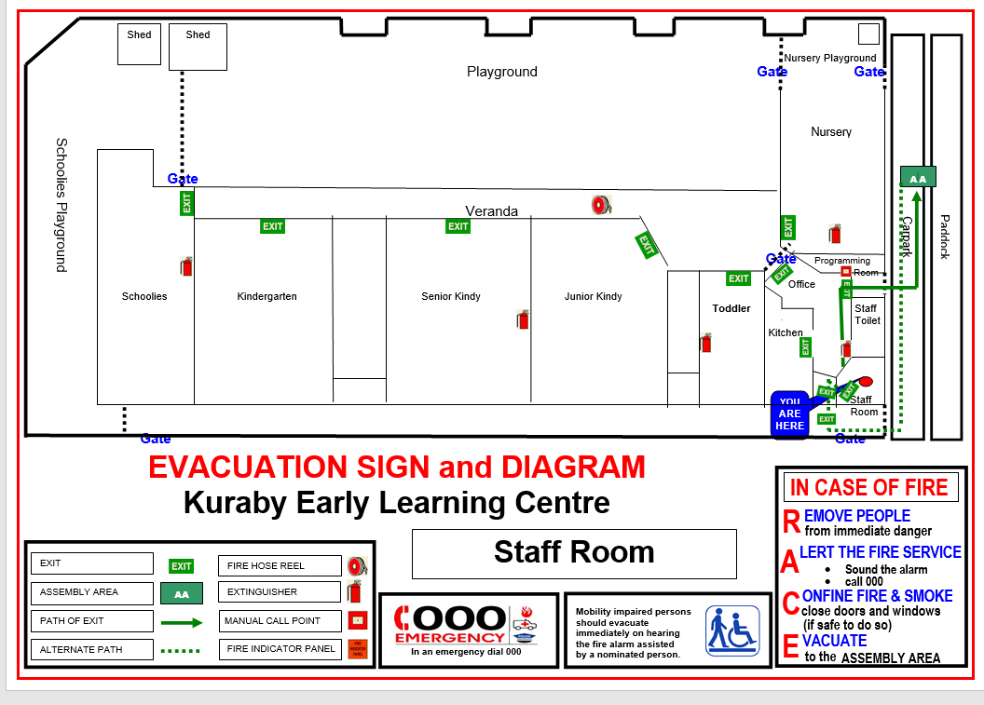
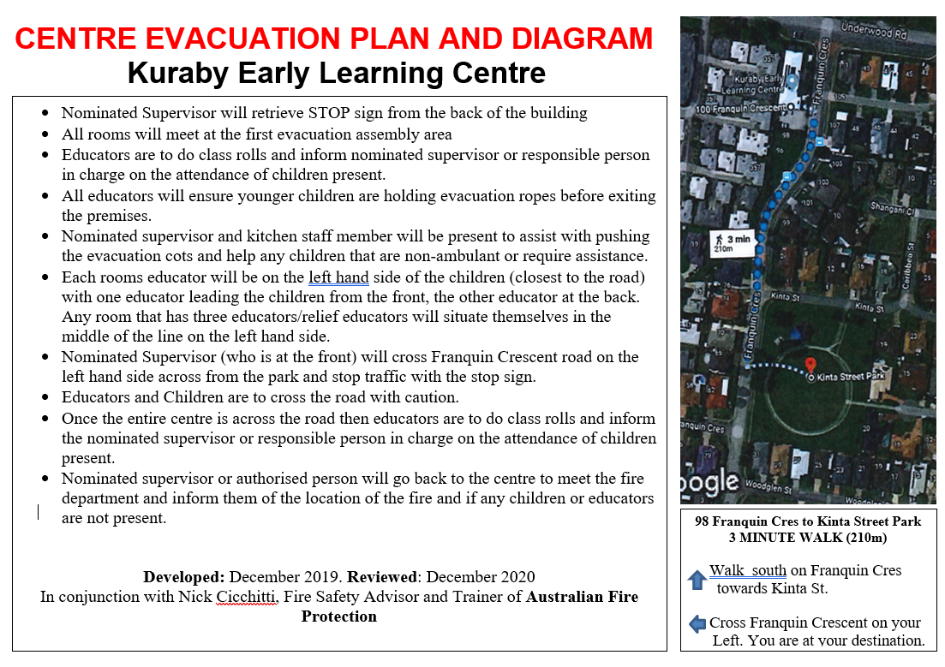

After Emergency

- Nominated Supervisor or responsible person ensures children or adults who are injured receive medical attention if required
- Nominated Supervisor or responsible person and educators contact parents/authorised nominees to collect children if required by the most appropriate method in the situation eg via email, Storypark message, telephone calls and phone texts e.g. building damaged and unsafe
  - tell parents/authorised nominees any relevant information eg areas to avoid, parking instructions, building damage, evacuation point.
- Nominated Supervisor or responsible person ensures educators stay on duty to care for and supervise children (after rostered hours if necessary) until families or relief staff arrive
- Nominated Supervisor or responsible person implements following where parents/emergency contact cannot be contacted, or are unable to get to the centre, to collect their child:
- contact parents/emergency contacts and authorised nominees every 15 minutes where previous attempts to make contact have been unsuccessful
- ensures there are sufficient numbers of service staff available (including relief staff) to adequately care for and supervise each child
- ensures child is never left alone with any adult unknown to staff, or not assisting in managing the emergency or child’s care in a professional capacity
- contact the police or Child Protection Services for advice if emergency is over and service staff are unable to stay with the child any longer
- Complete Incident, Injury, Trauma and Illness Record for children that have suffered an injury or trauma
- Get parent/guardian to sign Incident, Injury, Trauma and Illness Record and give them a copy
- File original Record in child’s file and record summary details in the Incident, Injury, Trauma and Illness Register, including time notified to Education and Care Regulatory Authority if relevant
- Approved provider notifies Education and Care Regulatory Authority of serious incident within 24 hours through NQS ITS and records summary details in the Serious Incident Register, including time notified to Regulator if relevant
  - File acknowledgement with Incident Record in child’s file
- If service closes approved provider reports closure and reason within 24 hours to:
- CCS Assessments CCSAssessments@dese.gov.au
- Education and Care Regulatory Authority
- any third-party software provider
Advise these agencies when service reopens.
- Approved provider notifies WorkSafe QLD as soon as possible about work-related incidents including where:
  - a person dies.
  - a person suffers a serious injury or illness.
  - there’s a dangerous incident (near miss)
See WorkSafe QLD for more information.
- File notification in WHS Register
- Debrief after emergency, review emergency plan and procedures, and implement any improvements to policy and procedures
- Record improvements in QIP

Lockdown procedures

Refer Lockdown Policy

Lockout Procedure

The following lockout procedure will be used when an internal immediate danger is identified, and it is determined that children should be excluded from buildings for their safety. Nominated Supervisor
- Activates lockout procedures.
- Announces lockout with instructions about what is required. Instructions may include nominating staff to:
- lock doors to prevent entry
- check the premises for anyone left inside
- obtain Emergency Kit.
- Contacts emergency services on 000.
- Goes to the designated assembly area.
- Checks that children, staff and visitors are all accounted for.

Actions after lockout
- Determine if there is any specific information staff, children, parents, and visitors need to know (e.g., areas of the facility to avoid).
- Ensure any children, staff, or visitors with medical or other needs are supported.
- Follow up with any children, staff or visitors who need support.
- Prepare and maintain records and documentation.
- Undertake operational debrief to review the lockout and procedural changes that may be required.
- Notify the Education and Care Regulatory Authority of incident as set out in our Incident, Injury, Trauma and Illness Policy.

Shelter-in-place procedures
Refer Bushfire and Grassfire Policy and Emergency Evacuation and Shelter in Place Procedures in case of bushfire or grassfire.

The following shelter-in-place procedure will be considered when an event takes place outside of the children’s service and emergency services determine the safest course of action is to keep children and staff inside a designated building in the children’s service until the external event is handled.

If a shelter-in-place action is determined the Nominated Supervisor

- activates shelter-in-place procedures.
- Moves all children, staff and visitors to the pre-determined shelter-in-place area.
- Obtains emergency kit.
- Notifies parents/families if the shelter-in-place is going to extend beyond the services hours of operation.
- Notifies the Education and Care Regulatory Authority of incident as set out in our Incident, Injury, Trauma and Illness Policy.

Emergency response procedures (specific emergencies)

FIRE
All staff will remain calm and report the outbreak of fire immediately to the Nominated Supervisor or Responsible Person who will:
- activate the fire alarm.
- Phone 000 to notify the fire brigade.
- Extinguish the fire (if safe to do so).
- Implement evacuation procedures if threat exists and close all doors and windows.
- Check that all areas have been cleared.
- Check children, staff and visitors are accounted for.
- Notify the Education and Care Regulatory Authority of incident as set out in our Incident, Injury, Trauma and Illness Policy.

BUSHFIRES/GRASS FIRES
Refer Bushfire Policy

SEVERE WEATHER /STORMS AND FLOODING
The Nominated Supervisor or Responsible Person will direct educators and staff to:
- Store or secure loose items external to the building, such as outdoor furniture.
- Secure windows (close curtains & blinds) and external doors. If necessary, tape windows and glass entrances. Utilise boards and sandbags if required.
- Protect valuables and disconnect electrical equipment – cover and/or move this equipment away from windows.
- (During a severe storm) remain in the building and ensure they and children keep away from windows. Restrict the use of telephone landlines to emergency calls only.
- Tune in to ABC radio if possible to follow any emergency instructions.
- Report to the Nominated Supervisor or Responsible Person regarding the status of children, staff and visitors safety.

After the storm passes, the Nominated Supervisor or responsible Person will evaluate the need to evacuate if uncontrolled fires, gas leaks, or structural damage has occurred as a result of the storm.

PANDEMIC
The Nominated Supervisor or Responsible Person will:
- Ensure basic hygiene measures are in place including the display of hygiene information.
- Provide convenient access to water and liquid soap and/or alcohol-based sanitiser.
- Educate staff and children about covering their cough to prevent the spread of germs.
- Stay alert and follow any instructions issued by Health authorities.
- Be prepared for multiple waves.
- Ensure spaces are well-ventilated – open windows if safe to do so or through mechanical air ventilation
- Notify Education and Care Regulatory Authority of incident as set out in our Incident, Injury, Trauma and Illness Policy.

BOMB/CHEMICAL THREAT
The Nominated Supervisor or Responsible Person will implement the following procedures:
- If a bomb/chemical threat is received by telephone:
- stay calm
- do not hang up
- refer to the bomb threat checklist.

- If a bomb/chemical threat is received by mail:
- avoid handling of the letter or envelope
- place the letter in a clear bag or sleeve
- inform the Police immediately.

- If a bomb/chemical threat is received electronically or through the service’s website:
- do not delete the message
- contact police immediately.

- Ensure doors are left open.
- Do not touch any suspicious objects found.
- If a suspicious object is found or if the threat specifically identified a given area, then evacuation may be considered.
- Notify Education and Care Regulatory Authority of incident as set out in our Incident, Injury, Trauma and Illness Policy.
Bomb/substance threat checklist

This checklist should be held by persons who regularly accept incoming telephone calls.
KEEP CALM
CALL TAKER |  | CALL TAKEN
Name |  | Date/Time:
Telephone # |  | Duration of call
Signature |  | Number of caller
Complete the following for a BOMB THREAT
QUESTIONS | RESPONSES
When is the bomb going to explode?
Where did you put the bomb?
What does the bomb look like?
What kind of bomb is it?
What will make the bomb explode?
Did you place the bomb?
What is your name?
Where are you going?
What is your address?
Complete the following for a SUBSTANCE THREAT
QUESTIONS | RESPONSES
When will the substance be released?
Where is it?
What does it look like?
When did you put it there?
How will the substance be released?
Is the substance a liquid, powder or gas?
Did you put it there?

CHARACTERISTICS OF THE CALLER
Sex of caller
Estimated age
Accent if any
Speech impediments
Voice (loud, soft, etc)
Speech (fast, slow etc)
Dictation (clear, muffled, etc)
Manner (calm, emotional, etc)
Did you recognise the voice?
If so, who do you think it was?
Was the caller familiar with the area?

LANGUAGE
[ ] Abusive | [ ] Taped
[ ] Well Spoken | [ ] Irrational
[ ] Incoherent | [ ] Message read by caller
[ ] Other (Specify)
BACKGROUND NOISE
[ ] Music | [ ] Local call
[ ] Machinery | [ ] Long Distance Call
[ ] Aircraft | [ ] Other (specify)

EXACT WORDING OF THREAT

ACTIONS
REPORT CALL TO:
ACTIONS:

MAJOR EXTERNAL EMISSIONS/SPILL (includes gas leaks)
The Nominated Supervisor or Responsible Person will:
- Call the Fire Brigade on 000.
- Turn off gas supply.
- If it’s a gas leak onsite, notify the gas provider (number can be found on the emergency numbers and key contacts page).
- Implement evacuation procedures.
- Check staff, children and visitors are accounted for.
- Await ‘all clear’ or further advice before resuming normal children’s services activities.
- Notify the Education and Care Regulatory Authority of incident as set out in our Incident, Injury, Trauma and Illness Policy.
- Notify WorkSafe QLD if required.

INTERNAL EMISSION/SPILL (e.g. cleaner’s storeroom)
The Nominated Supervisor or Responsible Person will:
- Move staff/children away from the spill to a safe area.
- If safe to do so, direct staff to clean the spill. Personal Protective Equipment should be worn as per the requirements of the Material Safety Data Sheet.
- Contact the Fire Brigade if the nature of the emission/spill is unknown or it is unsafe to manage.
- Notify WorkSafe QLD
- if required.

EARTHQUAKE
- Don’t panic.
If outside
The Nominated Supervisor or responsible Person will instruct staff and children to:
- Stay outside and move away from buildings, streetlights and utility wires.
- DROP, COVER and HOLD
- DROP to the ground
- Take COVER by covering their head and neck with your arms and hands
- HOLD on until the shaking stops.
If inside
The Nominated Supervisor or Responsible Person will instruct staff and children to:
- Move away from windows, heavy objects, shelves etc.
- DROP, COVER and HOLD
- DROP to the ground
- Take COVER by getting under a sturdy table or other piece of furniture or go into the corner of the building covering their faces and head in their arms
- HOLD on until the shaking stops.

After the earthquake the Nominated Supervisor or Responsible Person will:
- Evaluate the need to evacuate if there are uncontrolled fires, gas leaks or structural damage to the building.
- Instruct educators, staff, and children to watch out for fallen trees, power lines, and stay clear of any structures that may collapse.
- Ask educators and staff about the status of staff, children, and visitor safety.
- Arrange medical assistance where required.
- Instruct educators and staff to help others if possible.
- Tune in to ABC radio if possible, to follow any emergency instructions.

If there is damage to the facility and it is OK to do so, you may take notes and photographs for insurance purposes.

MEDICAL EMERGENCY
- Check for any threatening situation and remove or control it (if safe to do so).
- Remain with the casualty and provide appropriate support.
- Notify First Aid Officer and the Nominated Supervisor or Responsible Person.
- Notify the ambulance by dialling ‘000’.
- The Nominated Supervisor or responsible person will designate someone to meet and direct the ambulance to the location of the casualty.
- Do not leave the casualty alone unless emergency help arrives.
- Do not move the casualty unless exposed to a life-threatening situation.
- Refer “Administration of First Aid” in our Incident, Injury, Trauma and Illness Policy.
INTRUDER/PERSONAL THREAT
- Notify the Nominated Supervisor or responsible person who will request assistance from the police by dialling ‘000’.
- Do not do or say anything to the person to encourage irrational behaviour.
- Initiate action to restrict entry to the building if possible and confine or isolate the threat from building occupants.
- The Responsible person or Responsible Person determine if evacuation or lockdown is required. Evacuation only should be considered if safe to do so.

Appendix B

Emergency Communication Procedure
The approved provider will ensure there is access to reliable communication channels in the event of an emergency by maintaining access to a telephone (such as fixed-line telephone, mobile phone, satellite phone, 2-way radio, video conferencing equipment) at all times.
The main telephone is located at Office/Foyer If there is a complete loss of electricity and the telephones are not available, a mobile phone will be available and ready to use at all times to ensure educators can make emergency contact.

The nominated supervisor will, where possible:
- Listen to local radio stations (e.g., local ABC station) during emergencies to access current information about the situation.
- Ensure that families are provided with current information about an emergency situation, the actions taken to protect their child, and what actions families should take, through an accessible communication channel such as social media, service website, SMS or email. Multiple channels may be used to assist the flow of information.
- Ensure that current information about any service closure due to the emergency is provided through the same communication channels.
- Ensure current information about families’ emergency contact details is maintained. This may include families’ phone numbers and email addresses. The nominated supervisor will regularly remind families through service communications to update their contact details if required. This information is located in the Xplor app and they can change their details at any time.
Appendix C
Emergency Drill/Exercise ‘Observer’ Record
Item | Yes | No
Item | ü | ü
Were emergency services briefed on exercise prior to exercise being started?
Did the person discovering the emergency alert the other occupants?
Was the alarm activated?
Was the emergency service notified promptly?
Did staff direct persons from the building/site per the evacuation procedures?
Were isolated areas searched?
Was the evacuation logical and methodical?
Did someone take charge? If yes, who?
Did occupants act as per instructions?
Was a roll call conducted for:
Children
Staff
Visitors (including contractors and volunteers)
Was someone appointed to liaise with the emergency service/s?
Was someone appointed to liaise with the parents/community?
Was the emergency service given the correct information?
Did anyone re-enter the premises before the “all clear” was given?
Did anyone refuse to leave the building/site?
Area of Emergency plan tested by current exercise:

FIRE EVACUATION DRILL REGISTER

Date: -----/-----/----- Time: ____________________
Person conducting the drill: ________________ Signature:___________________________
Fire location: ______________________________________________________________________
Were all roles collected: ______________________________________________________________________
Were all staff and children accounted for: ______________________________________________________________________
Were the staff and children calm and orderly: ______________________________________________________________________

How many children in Babies room: ______________________________________________________________________
How did the children perform? ______________________________________________________________________

How many children in Toddlers room: ______________________________________________________________________
How did the children perform? ______________________________________________________________________
How many children in Jk Kindy room: ______________________________________________________________________
How did the children perform? ______________________________________________________________________

How many children in Sr Kindy room: ______________________________________________________________________
How did the children perform? ______________________________________________________________________

How many children in Preschool room: ___________________________________________________________________
How did the children perform? ___________________________________________________________________

How many children in School Care room: ___________________________________________________________________
How did the children perform? ___________________________________________________________________

Which exits were used? ___________________________________________________________________
Did they function correctly? ___________________________________________________________________
Time Completed: _____________________________________________________

Suggestions for improvement, follow up on any problem areas, training ideas or any other matters concerning safety? _______________________________________________________________________________________________________________________________________________________________________________________________________________

Staff Members involved:
Name: ________________________________ Signature: _______________________ Name: ________________________________ Signature: _______________________ Name: ________________________________ Signature: _______________________ Name: ________________________________ Signature: _______________________ Name: ________________________________ Signature: _______________________ Name: ________________________________ Signature: _______________________ Name: ________________________________ Signature: _______________________ Name: ________________________________ Signature: _______________________ Name: ________________________________ Signature: _______________________ Name: ________________________________ Signature: _______________________ Name: ________________________________ Signature: _______________________ Name: ________________________________ Signature: _______________________ Name: ________________________________ Signature: _______________________ Name: ________________________________ Signature: _______________________ Name: ________________________________ Signature: _______________________ Name: ________________________________ Signature: _______________________ Name: ________________________________ Signature: _______________________ Name: ________________________________ Signature: _______________________ Name: ________________________________ Signature: _______________________ Name: ________________________________ Signature: _______________________ Name: ________________________________ Signature: _______________________

Any General Comments:
______________________________________________________________________________________________________________________________________________________________________________________________________________________________________________________________________________________________________________________________________________________________________________________________________________________________

Nominated Supervisor/ Responsible person in charge: Lisa Campbell
Directors Signature: ______________________
Date: ___________________

Lock Down Drill Register
Date: ___/___/___ Time Started: ______ am/pm (please circle)
Person Conducting the Drill: _______________ Signature:__________________________________
Reason for Lock down:______________________________________________________________ ________________________________________________________________________________
Were all rolls and tablets collected: ____________________________________________________
Were all Children and Educators accounted for: __________________________________________
Were all the Children and Educators calm and orderly: _____________________________________

Room | Educator | Co-Educator | Co-Educator | Visitors/  Students | Total Number of Children
Nursery
Toddler
Jr Kindy
Sr Kindy
Kindergarten
Schoolies

Were phones answered: __________________________________________________
Did they function correctly: ________________________________________________
Time Completed: ________________________________________________________

Suggestions for improvement , Follow up on any problem areas, training ideas or any other matters concerning safety plus any general comments: ____________________________________________________________________________________________________________________________________________________________________________________________________________________________________________________________________________

Nominated Supervisors Name: Lisa Campbell
Nominated Supervisors Signature: ________________________
Date: _______________________________________________

Appendix D

Risk assessment template for emergencies
